Brothers and Sisters in Christ,
As I mentioned at the end of all the Masses on Ascension weekend (May 20th-21st), the Illinois Attorney General has indeed released their report this week which is the culmination of a multi-year review of the Illinois Catholic dioceses' response to the child sexual abuse scandals.
The release of this report undoubtedly resurfaces great pain for those who were harmed by priests and other representatives of the Church. There is no excuse for the horrific abuses and negligent leadership that took place in the decades leading up to the 2002 ‘Spotlight’ revelations.
As your priest and pastor, and as a representative of the Catholic Church, I offer my deepest apologies and sorrow to those hurt by the leadership of the Church. Such sin and scandal of this magnitude will never be forgotten—nor should it be, as we have continued since then to do everything possible to avoid such atrocities in the future. I encourage you to take a few moments to view Bishop Hicks’ responses to the report: to read his statement on the diocesan website and to watch his video responses there as well.
Thankfully, over the last 20 years, diocesan policies have been extremely effective at eliminating abuse and ensuring that no one serving within our clergy, deaconate, seminaries, schools, ministries, or parishes are known abusers of children. The Diocese of Joliet has a zero-tolerance policy regarding sexual abuse and reports all allegations of the abuse of minors to the proper state authorities. This means that there is no one with a substantiated allegation of the abuse of a minor working in our Diocese. All clergy, volunteers working with children, and staff are background-checked and trained to prevent, spot, and report potential abuse. Find out more about what is being done to protect youth and vulnerable persons at protect.diojoliet.org.
Please join me this Pentecost weekend, in calling upon the Holy Spirit to bring healing, justice, and forgiveness to those who have been hurt by the leaders of the Church.
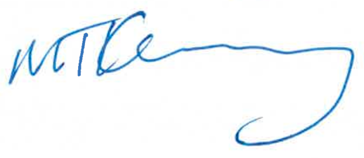
Yours in Christ,

Reverend Michael T. Kearney
Pastor
________
Enclosures
- Statement of Bishop Ronald A. Hicks on the Illinois Attorney General Report dated May 23, 2023
- Bishop Hicks Videos on the Attorney General Report
- U.S. Conference of Catholic Bishops Prayer for Healing Victims of Abuse
- Illinois Attorney General Report on Catholic Clergy Child Sex Abuse 2023

